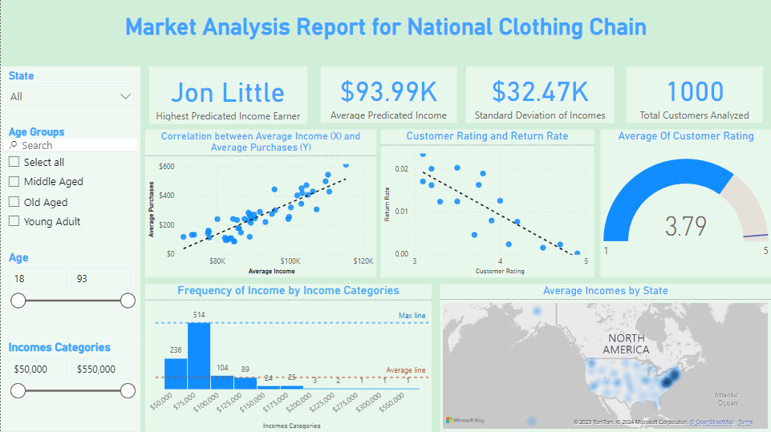**Summery:**

The summary page provide an overview of the solutions to the business problems listed above. It contains visuals from the other four pages with each visual addressing a particular business problem.

**Average Income vs Average Sales:**

* There is a strong positive correlation between Average Income and Sales with a correlation coefficient of 0.78
* 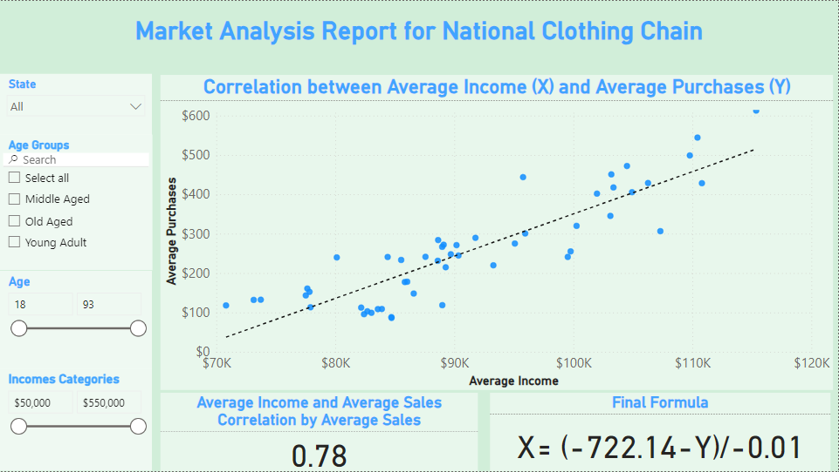The regression formula: x = -722.14 – y / -m

**Customer Analysis:**

* Jon Little is predicted to be the highest income earner. This was achieved using the regression formula: x = -722.14 – y / -m
* 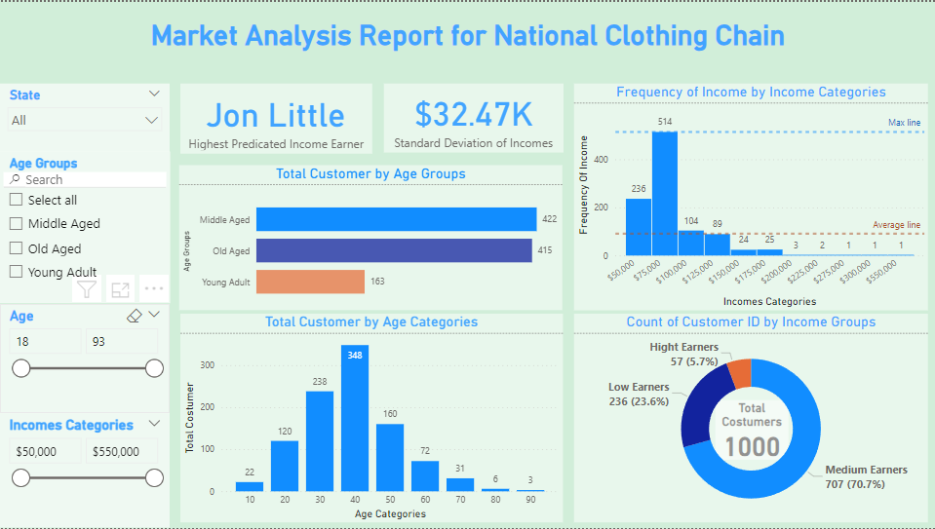About 71% of customers are medium income earners

**Product Analysis:**

* There is a strong negative correlation between customer ratings and product return rate with a correlation coefficient of 0.69
* Chronograph Watch is the best rated product with a rating of 4.90
* Winter Gloves and Wool Scarf are the least rated products with a rating of 3.10
* 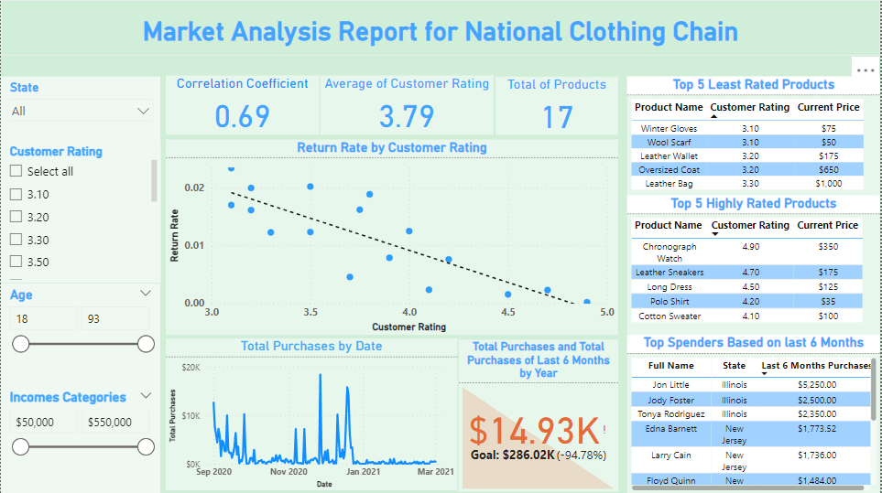Based on customer transaction data from September 2020 to March 2021, 80% of top 10 customers (spenders) are from Illinois and New Jersey

**Geographical Analysis**

* District of Columbia, New Jersey, Maryland, Massachusetts, Hawaii, California, Connecticut, Washington,Colorado and New Hampshire are the top 10 states based on average income while Mississippi, West Virginia, Arkansas, Kentucky, New Mexico, Louisiana, Alabama, Oklahoma, Tennessee and Montana are the bottom 10 states based on average income.
* 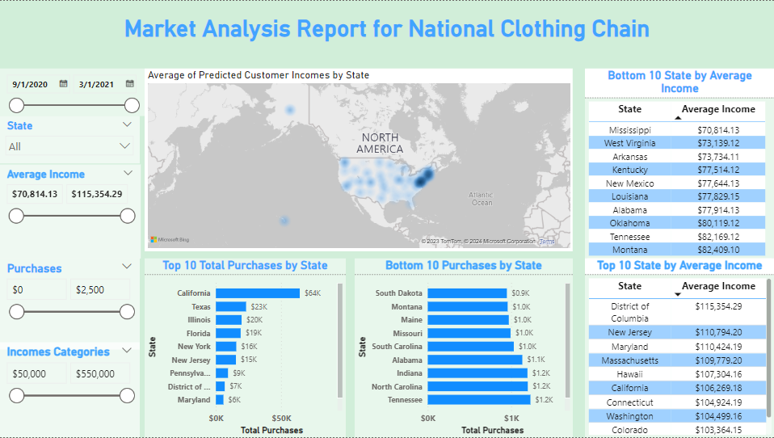Texas, Illinois, Florida, New York and New Jersey are the Top 5 most Purchases States While South Dakota, Montana, Maine, Missouri and South Carolina are the Bottom 5 most Purchases States .

**Recommendation**

* Leather bag is one of the least rated products. For this reason, I suggest that among the three suggested products, Leather bag should be advertised the most. Again, it should be marketed in the higher income states.
* Shirts, in all have a favorable rating at a fairly good price. Of all the four different kinds of shirts, Polo Shirt is the best rated product. These products could be marketed in almost all the states.